JAVA ASSIGNMENT-10 (20/11/2018)

Write a java progarm to implement the following relationship
a)An Employee has Temperory and Permenent address.

package raj;
class TempAddress
{
int doorno;
String street;
String area;
long pin;
public TempAddress(int doorno, String street, String area, long pin) {

this.doorno = doorno;
this.street = street;
this.area = area;
this.pin = pin;
}

}
class PermanentAddress
{
int doorno;
String vill;
String city;
long pin;
public PermanentAddress(int doorno, String vill, String city, long pin) {

this.doorno = doorno;
this.vill = vill;
this.city = city;
this.pin = pin;
}

}
class Employeedetails
{
int empid;
String empname;
String compname;
double salary;
TempAddress taddr;
PermanentAddress paddr;
public Employeedetails(int empid, String empname, String compname, double salary, PermanentAddress paddr, TempAddress taddr) {

this.empid = empid;
this.empname=empname;
this.compname = compname;
this.salary = salary;
this.taddr=taddr;
this.paddr=paddr;
}
void printData()
{
System.out.println("Employee id is:"+empid);
System.out.println("Employee name is:"+empname);
System.out.println("Company name is :"+compname);
System.out.println("Salary is: "+salary);
System.out.println("Permanent address is : "+paddr.doorno+" "+paddr.vill+" "+paddr.city+" "+paddr.pin);
System.out.println("Temperary address is :"+taddr.doorno+" "+taddr.street+" "+taddr.area+" "+taddr.pin);
}
}
public class Employee {

public static void main(String[] args) {
PermanentAddress obj=new PermanentAddress(12,"nekkonda","warangal",506122);
TempAddress obj2=new TempAddress(22,"ameerpet","hyd",500012);
Employeedetails obj3=new Employeedetails(236,"raju","scls",25000,obj,obj2);
obj3.printData();
}

}

Output:
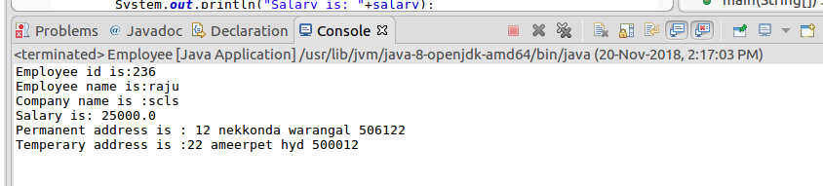

b)Every car has engine

package raj;
class Mechanical
{
String part1;
String part2;
String part3;
String part4;
String part5;
String part6;
String part7;
String part8;
public Mechanical(String part1, String part2, String part3, String part4, String part5, String part6, String part7,
String part8) {
super();
this.part1 = part1;
this.part2 = part2;
this.part3 = part3;
this.part4 = part4;
this.part5 = part5;
this.part6 = part6;
this.part7 = part7;
this.part8 = part8;
}

}
class Electrical
{
String ecomponent1;
String ecomponent2;
String ecomponent3;
String ecomponent4;
String ecomponent5;
public Electrical(String ecomponent1, String ecomponent2, String ecomponent3, String ecomponent4,
String ecomponent5) {
super();
this.ecomponent1 = ecomponent1;
this.ecomponent2 = ecomponent2;
this.ecomponent3 = ecomponent3;
this.ecomponent4 = ecomponent4;
this.ecomponent5 = ecomponent5;
}

}
class CarData
{
String name;
int speed;
String s1;
String s2;
Mechanical mcomp;
Electrical ecomp;

public CarData(String name,int speed,String s1, String s2, Mechanical mcomp, Electrical ecomp) {
super();
this.name=name;
this.speed=speed;
this.s1 = s1;
this.s2 = s2;
this.mcomp = mcomp;
this.ecomp = ecomp;
}

void carengineData()
{
System.out.println("Name of car: "+name);
System.out.println("Speed of car: "+speed+"mph");
System.out.println("Car has anyone of below two engines");
System.out.println("1)"+s1);
System.out.println("2)"+s2);
System.out.println("Mechanical components are");
System.out.println("------------------------------");
System.out.println(mcomp.part1+" "+mcomp.part2+" "+mcomp.part3+" "+mcomp.part4+" "+mcomp.part5+" "+mcomp.part6+" "+mcomp.part7+" "+mcomp.part8);
System.out.println("Electrical components are");
System.out.println("--------------------------------");
System.out.println(ecomp.ecomponent1+" "+ecomp.ecomponent2+" "+ecomp.ecomponent3+" "+ecomp.ecomponent4+" "+ecomp.ecomponent5);
}
}
public class Car {

public static void main(String[] args) {
Mechanical obj1=new Mechanical("CYLINDER,","PISTON,","CRANKSHAFT,","CONNECTING ROD,","CYLINDER HEAD,","VALVES,","OIL PUMP AND SUMP,","FUEL PUMP");
Electrical obj2=new Electrical("ALTERNATOR,","STARTER MOTOR,","SPARK PLUG,","IGNITION COIL,","ELECTRONIC FUEL INJECTOR");
CarData obj3=new CarData("Ferrari Monza SP2",186,"I.C Engine ","E.C Engine ",obj1,obj2);
obj3.carengineData();

}

}

Output:
